CHECKLIST
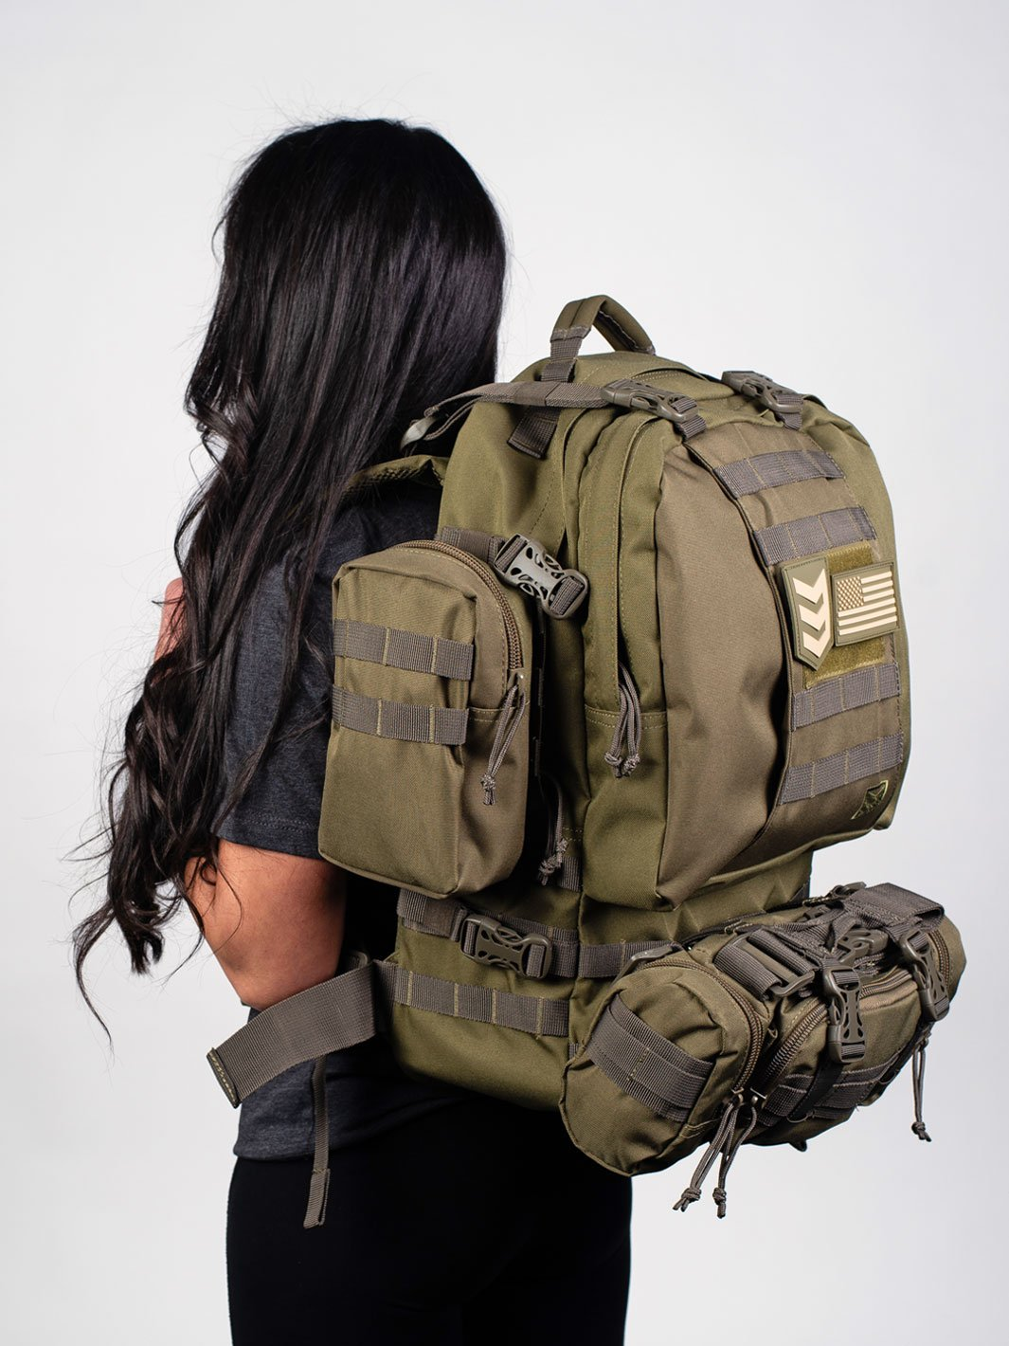
3V Gear Paratus 3-Day Pack

Website

I have this pack in black. There’s 2 removable
MOLLE pouches and a removable deployment
pack. I use one MOLLE pouch for a fire kit and
the other for a water treatment/filtration kit.
_________________________________________________________________________________________________
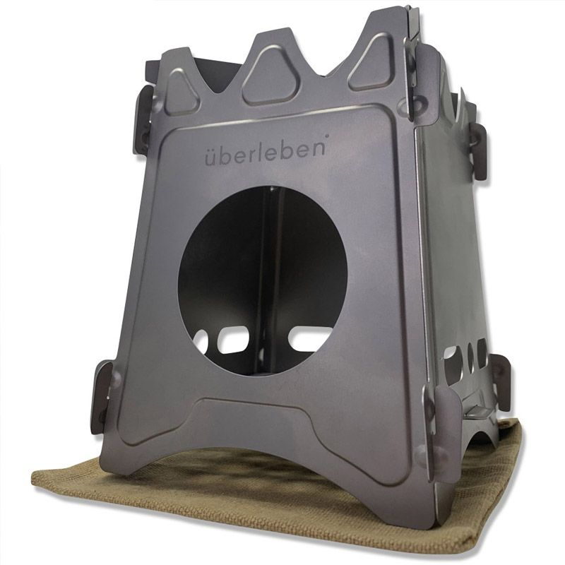
Uberleben Stoker Titanium

Website

Comes with a waxed canvas storage bag. Packs
flat and very lightweight.

___________________________________________________________________________________
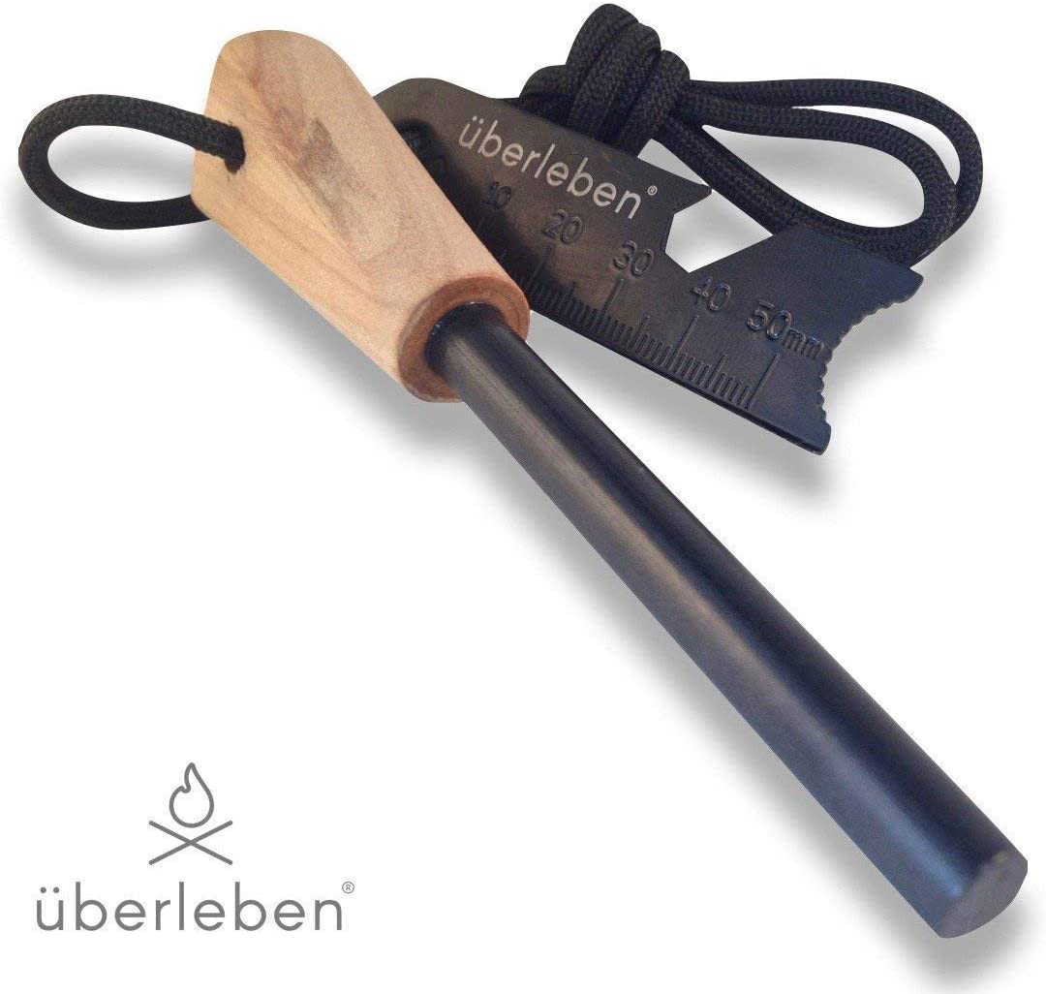

Uberleben Fire Starter

Website

Find a video to watch how this works to start a fire.
Save your dryer lint. Great fire starter.
___________________________________________________________________________________
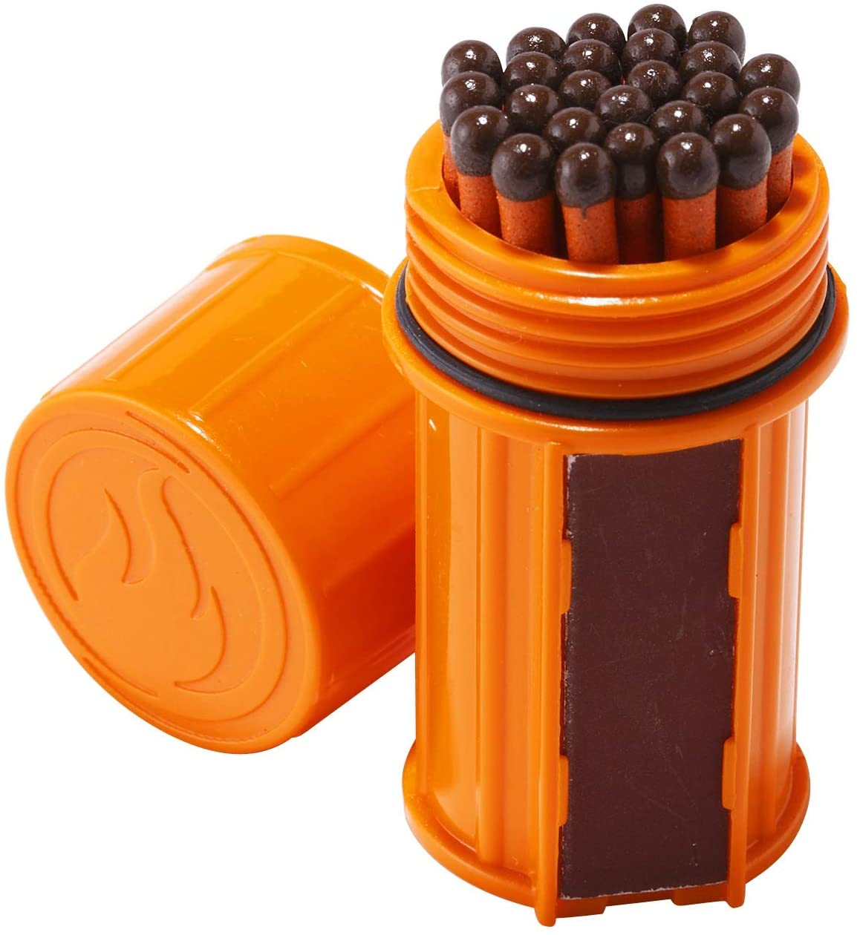

UCO Storm Proof Match Kit

Website

These matches will light when wet. Once lit, you
can plunge the match under water, remove from
water, and it will relight.

___________________________________________________________________________________
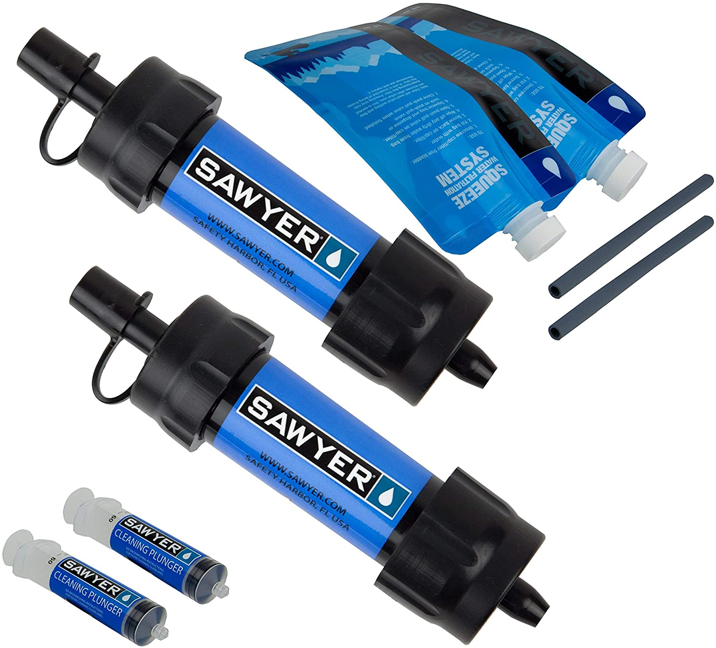
Sawyer Water Filter

Website

Always have two on hand. If you lose one,
you have a backup.

___________________________________________________________________________________

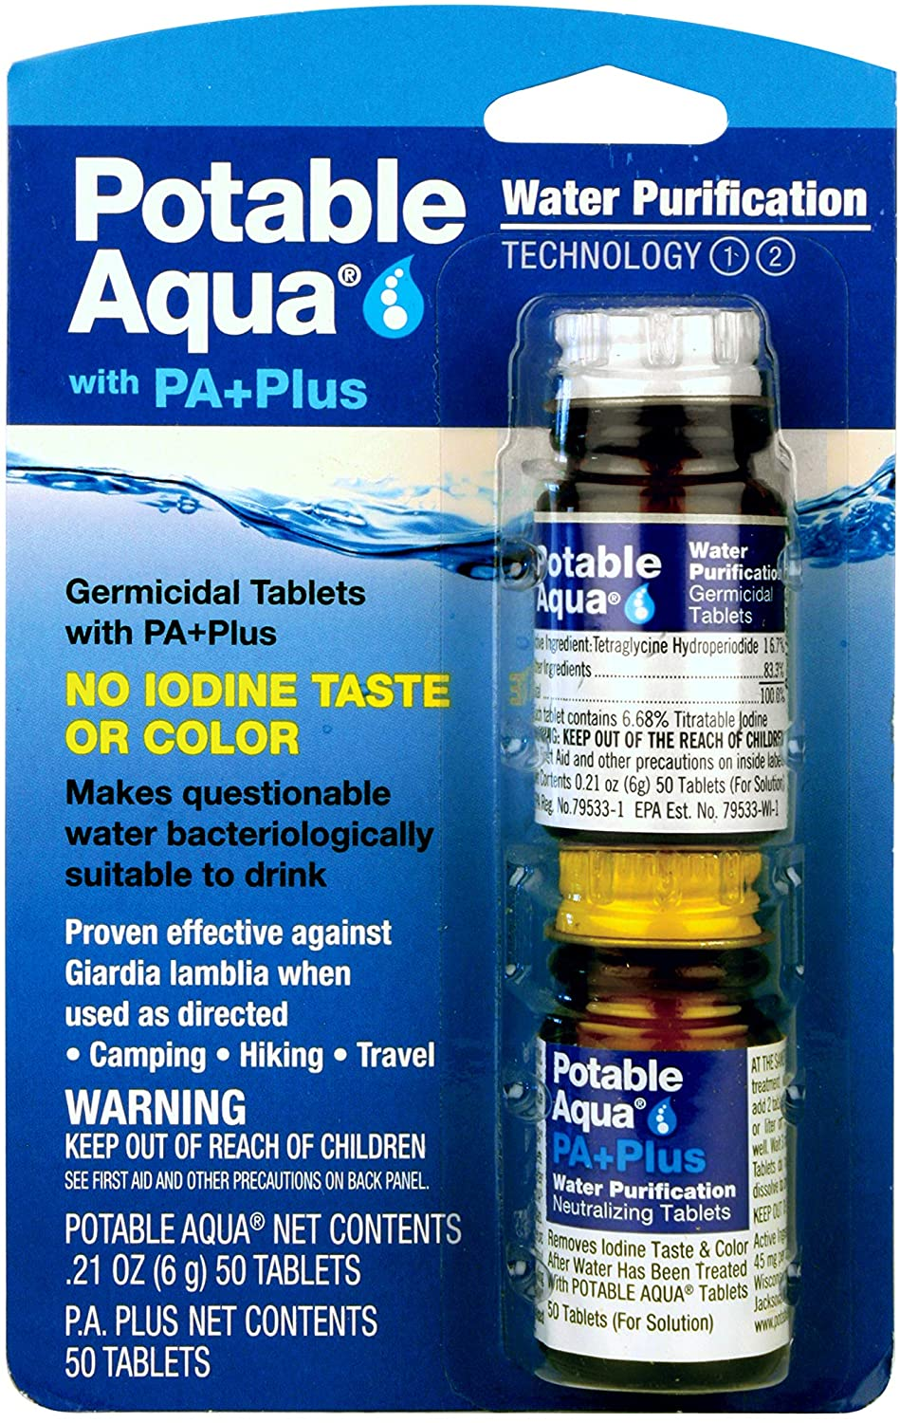
Aqua Water Purification Tablets

Website

2 tablets will purify a 32 oz. Nalgene bottle
of water. Takes 30 minutes to be effective.
Neutralizes giardia and cryptosporidium.

_________________________________________________________________________________________________

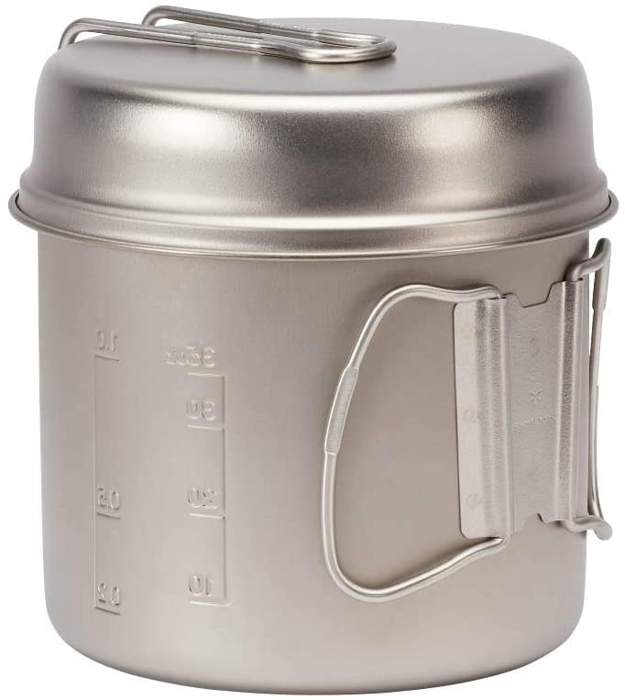
Snow Peak Trek 1400 Titanium

Website

I have this as my cook kit. Very light weight.
30 fl oz water/soup container and the lid
doubles as a skillet.

_________________________________________________________________________________________________

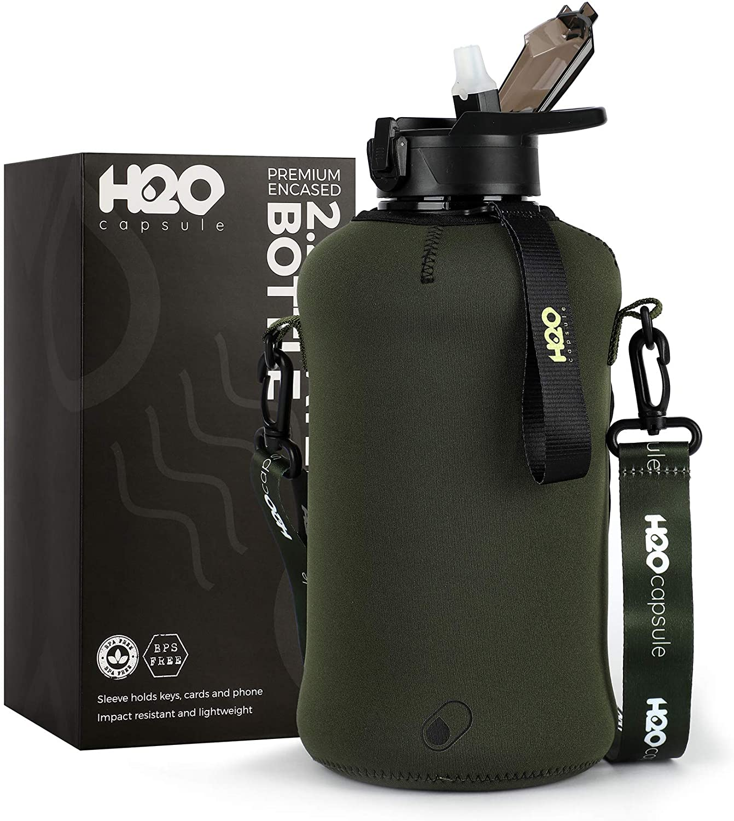
H20 Water Capsule ½ Gallon

Website

This is for storing filtered clean water.
I bought mine 4 years ago and it’s
still going strong.

The above are the most important items to have in a bug out kit. There is the question of shelter and I will cover that later.

Survival Rule of 3 and Survival Priorities
For real survival situations it is better to remember and prioritize by the four levels of the Survival Rules of 3:

- You can survive for 3 Minutes without air (oxygen) or in icy water.
- You can survive for 3 Hours without shelter in a harsh environment (unless in icy water).
- You can survive for 3 Days without water (if sheltered from a harsh environment).
- You can survive for 3 Weeks without food (if you have water and shelter).

Shelter and Environmental Protection

- Fire Starting Kit
- Emergency Blanket
- Poncho
- Sleeping Bag
- Tarp
- Tent
- Paracord
- Spare Clothes (above anything else, be sure to have 2 pair of clean wool socks)

* I have a heavy duty tarp and a lined poncho that I will use for a shelter, versus the bulk of a tent system. YouTube is a great resource for learning how to build shelters with poncho/tarp.

Food and Water

- Water
- Rations (MRE, Emergency Food Bars, Dried fruit and nuts, etc.)
- Water Filtering Item
- Water Purification Tablets
- Canteen
- Hydration Bladder
- Can Opener (Military P38 and/or P51. Small, lightweight and takes up little room.)
- Eating Utensils (UCO Titanium Utility Spork)

Communication and Navigation

- Emergency Radio (HQ ISSUE Digital Multi-Band Solar Powered/Hand Crank Radio)
- Flashlight (I use Olight brand. Small, rugged, different brightness levels up to 2000 lumens.)
- Headlamp (Olight Perun 2 headlamp great for hands free lighting.)
- Survival Whistle
- Compass
- Laminated State Map
- Chemical Light Sticks
- Signal Mirror
- Cell Phone Cable and Adapter (Power Bank. My brand of choice is Anker.)

First Aid and Staying Healthy

- First Aid Kit (Ibuprofen/Acetaminophen, burn cream, triple antibiotic ointment, band aids, dressings, Q-tips, butterfly sutures, prescription meds, etc.)
- Tourniquet
- Israeli Bandage
- Sam Splint
- QuickClot
- Bug Repellent
- Hygiene Kit
- Wet Naps
- Potassium Iodide Tablet

*Create a dedicated kit that’s easily accessible for first aid/hygiene items. I use a Maxpedition Gear Beefy Pocket Organizer. This bag is ALWAYS on top inside of my go bag.

Miscellaneous

- Multitool (Leatherman Tools)
- Folding Knife
- Fixed Blade Knife
- Paracord
- Duct Tape or Gorilla Tape (You don’t need to carry an entire roll. I have several Bic lighters here and there in my go bag. I wrap each one, along the middle of the lighter, with about a 1” thick wrap of Gorilla tape.}
- Batteries
- Solar Charger
- Zip Ties
- Bandana or Shemagh
- Dry Bag
- Pocket Survival Guide (I have a pocket guide called, SAS Survival Handbook, Third Edition: The Ultimate Guide to Surviving Anywhere.)

Wilderness Survival Gear

- Fishing Kit (Uncle Flint's Survival Fishing Kit. Compact fishing kit in a 4x3x1 inch tin. All that’s needed is a pole, which can be fashioned from a tree branch with a tomahawk and knife. Website)
- Hatchet or Tomahawk (Either one of these can be attached to the outside of your pack.)
- Filet Knife

Self-Defense

- Pepper Spray (Preferably, bear repellent.)
- Handgun & Ammo (I use the removable deployment pack, from my 3V Gear Paratus pack, to store my handgun and ammo.)
- Rifle & Ammo (As above, I store my AR-15 ammo in the deployment pack. The rifle is fitted with a 3-point sling and goes over my shoulder and across the front of my body. It’s always in the low-ready position.)

Personal Items

- Cash (I keep $300.00 hidden in my medical kit.)
- Small Notebook (I use Rite in the Rain Weatherproof Top-Spiral Notebook, 3" x 5".)
- Pen
- Identification (photocopies) and Emergency Contacts
- Prescription Medication Information

REMEMBER: Don’t just pack everything on this list. Instead, limit your bag’s contents based on your specific needs, environment, and potential threats.

Also, make sure your bag, once packed, weighs around 25% of your body weight.

All of this may seem overwhelming and expensive. Not to mentioned knowing how to use all of the items in your pack. Most of the items are small and will fit in your pack. You will need to remember to rotate out any food, batteries, and first aid supplies that have expired or soon to expire.

I tear down my pack once every 3 months to check for expired items and make sure everything is in working order. Familiarize yourself with everything in your pack and learn how to use each and every item. Practice in the backyard. It’s fun! Any questions, please feel free to let me know.

